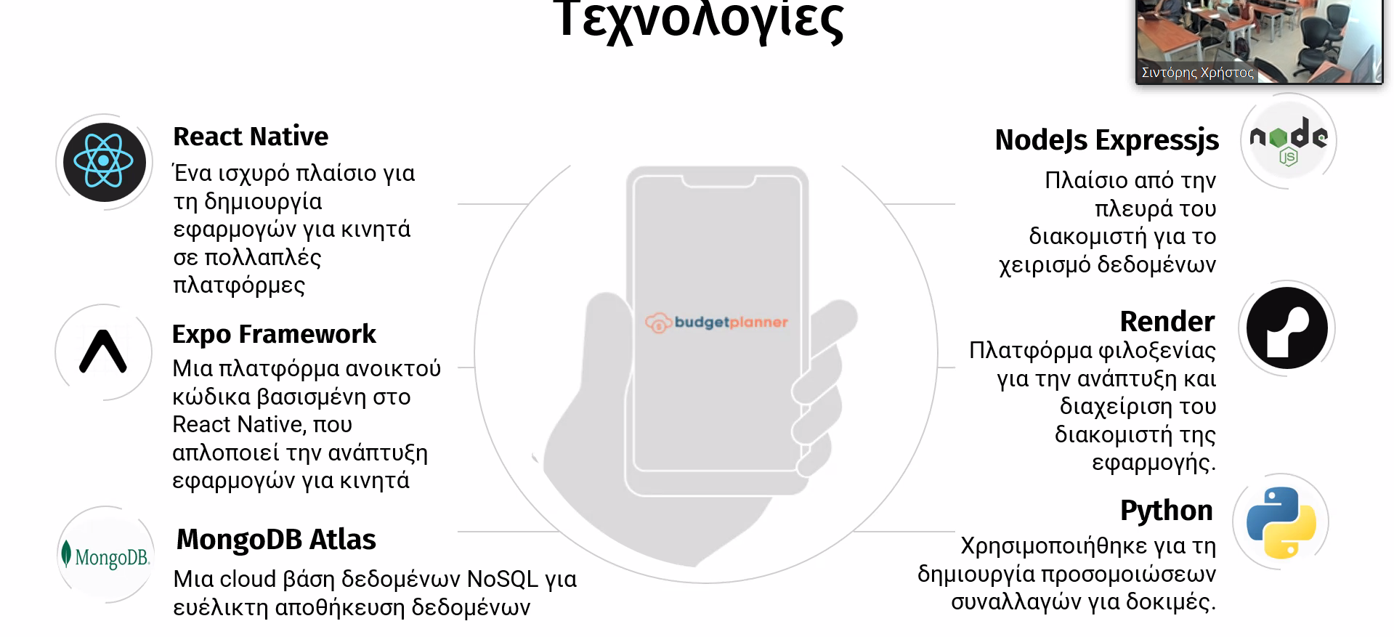
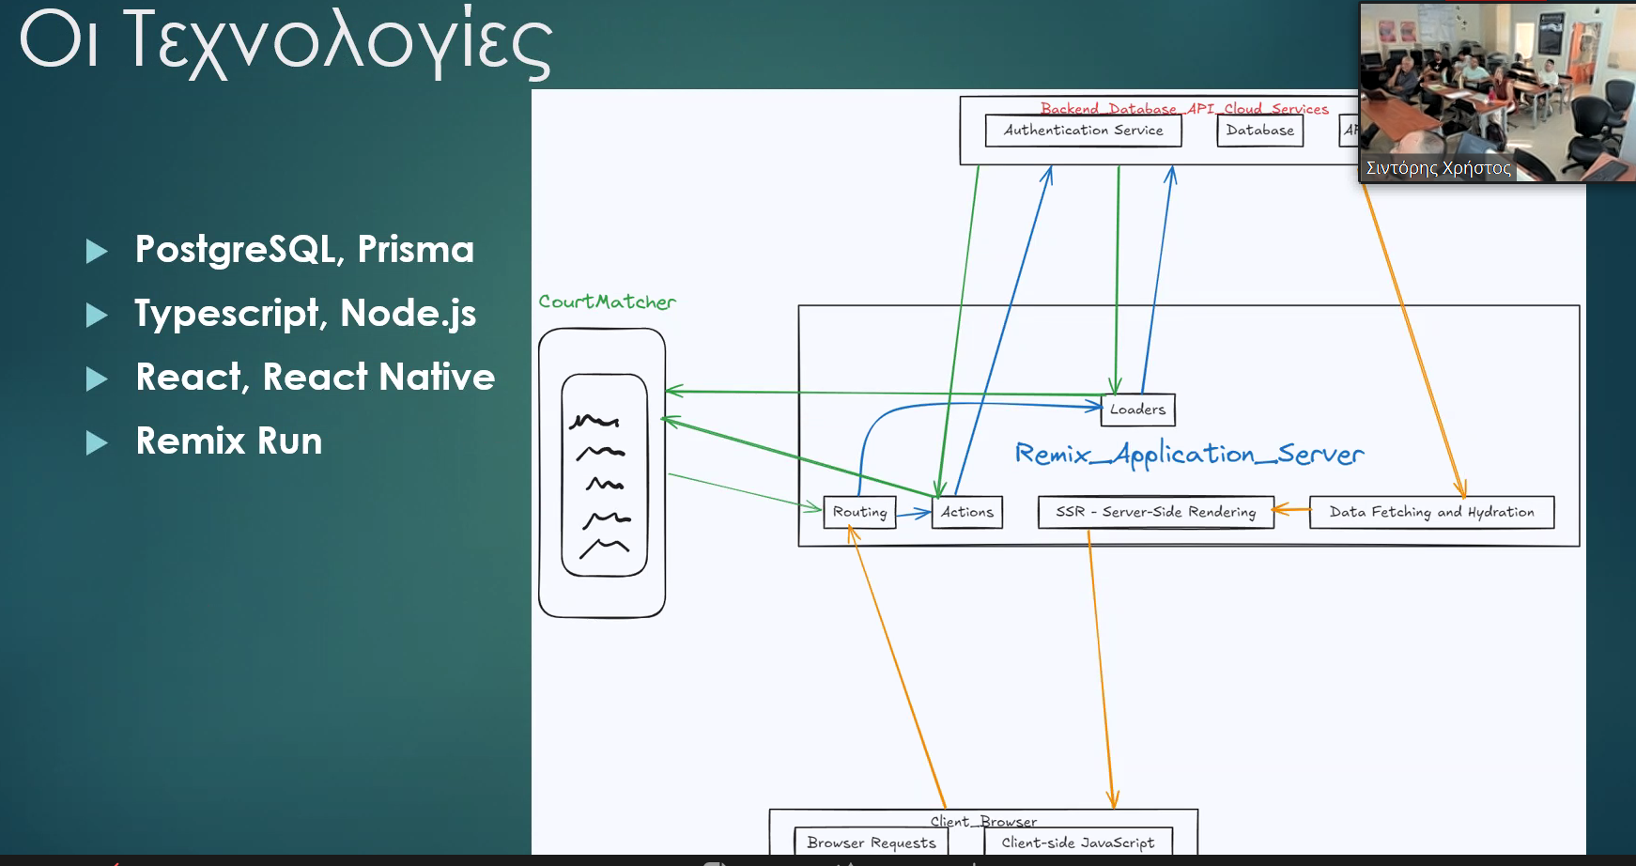
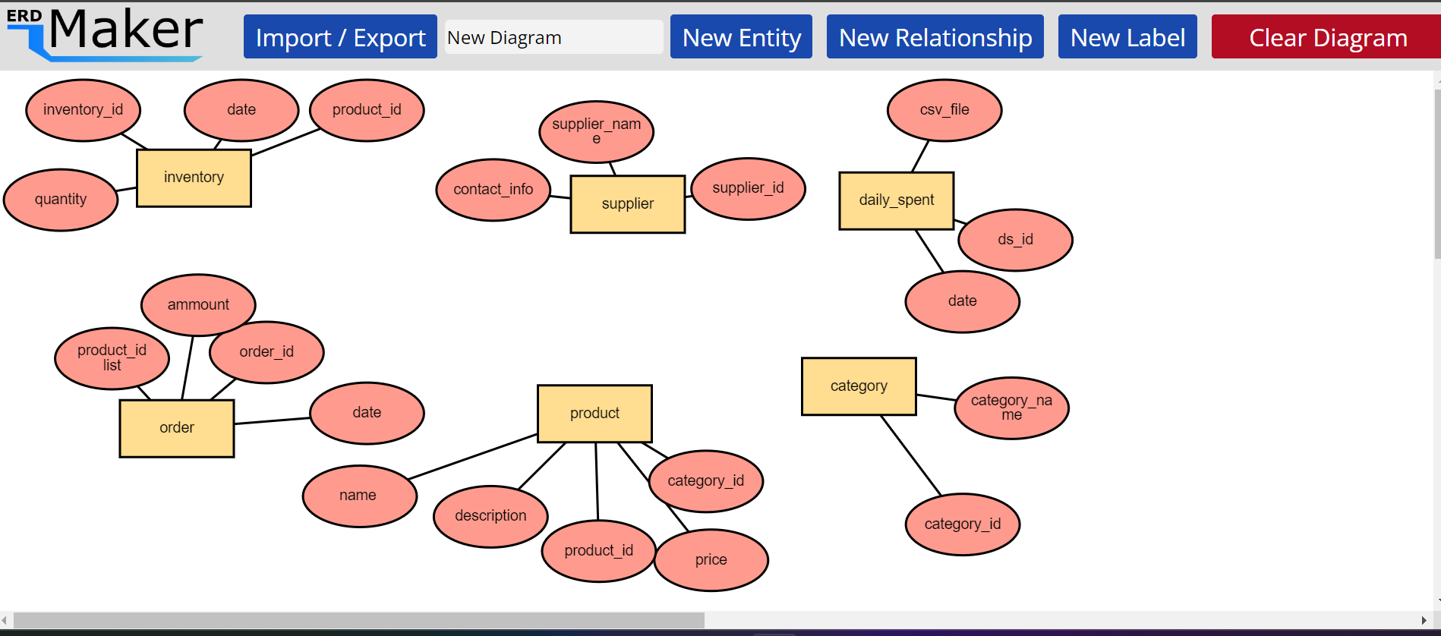


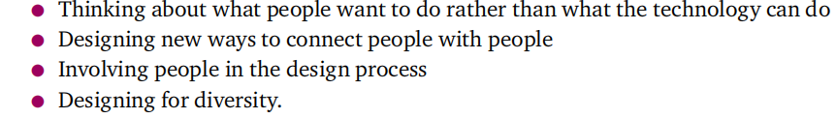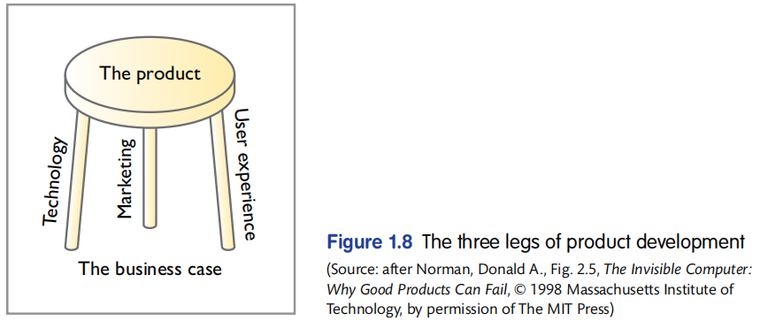
People develop mental models through interacting with systems, observing the rela
tionship between their actions and the behaviours of the system, and reading any
manuals or other forms of explanation that come with a system. So, it is important that
designers provide sufficient information in the interface (and any accompanying docu
mentation) for people to form an accurate mental model.

ADOBE COLOR
colorhunt.co

2 Fonts for a design

UX
- Simplicity
- Consistency
- Reading patterns( The F layout or Z layout)
- All platform Designs
- Don’t Use powers for evil (Dark patterns)

Zampon

Four processes for UX: understanding,design,envisioment,evaluation
Scenarios
PACT on inventory system design:

